A134-Eur-Germany-Hohle Fels Cave-Water Bird-33,000 BP

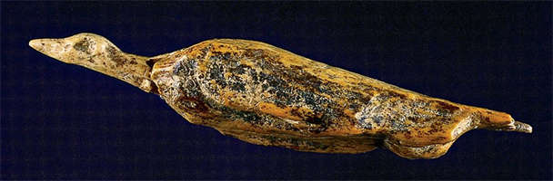

A134-Eur-Germany-Hohle Fels Cave-Water Bird-33,000 BP

**Fig. 1.** Germany-Hohle Fels Cave-Water Bird-33,000 BP

**Formal Label:** Germany-Hohle Fels Cave-Water Bird-33,000 BP

**Display Description:** This is one of the non-human figurines found in Hohle Fels Cave dating to 33,000 BP. The cave was a repository of many human and animal figurines but this is the unique bird figurine in mammoth ivory. The back is etched with transverse lines representing feathers. This suggests that perhaps the pose of the bird and these etchings may be related. From other cave contexts we know that entoptic images were perceived in hallucinogenic contexts. The pose of the bird is as if diving, and this also suggests that it is in a state of submersion. It has been suggested that since the caves also served as the repositories of figurines they may have been used in a religious context (UNESCO).

**Accession Number:** A134

**LC Classification**: CC77.5

**Date or Time Horizon:** 33,000 BP-31,000 BP

**Geographical Area:** Germany-Hohle Fels Cave

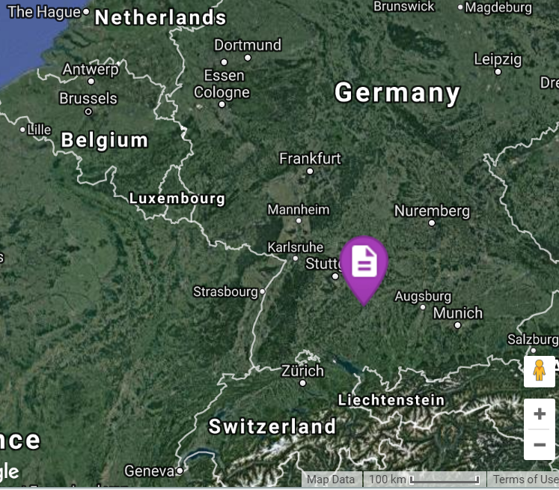

**GPS coordinates: 48°22'26.99" N 9°45'11.99" E**

**Cultural Affiliation:** Paleolithic

**Medium:** mammoth ivory.

**Dimensions:**

**Weight:**

**Condition: replica in resin.**

**Provenance:** Louvre Museum, Paris.

**Discussion:** There has been little attention given to this figurine, but its diminutive size and lack of suspension loop as a personal amulet suggests that its role in rituals in the cave may have been communal.

**References:**

Miller, Chrisatopher E. [*A tale of two Swabian caves: geoarchaeological investigations at Hohle Fels and Geißenklösterle*](https://getit.library.nyu.edu/resolve?&ctx_ver=Z39.88-2004&ctx_enc=info:ofi/enc:UTF-8&ctx_tim=2017-12-04T16%3A23%3A55IST&url_ver=Z39.88-2004&url_ctx_fmt=infofi/fmt:kev:mtx:ctx&rfr_id=info:sid/primo.exlibrisgroup.com:primo-nyu_aleph004199526&rft_val_fmt=info:ofi/fmt:kev:mtx:book&rft.genre=book&rft.jtitle=&rft.btitle=A%20tale%20of%20two%20Swabian%20caves%20:%20geoarchaeological%20investigations%20at%20Hohle%20Fels%20and%20Gei%C3%9Fenkl%C3%B6sterle&rft.aulast=Miller&rft.aufirst=Christopher%20E.,&rft.auinit=&rft.auinit1=&rft.auinitm=&rft.ausuffix=&rft.au=Miller,%20Christopher%20E.,%201982-&rft.aucorp=&rft.volume=&rft.issue=&rft.part=&rft.quarter=&rft.ssn=&rft.spage=&rft.epage=&rft.pages=&rft.artnum=&rft.pub=Kerns%20Verlag&rft.place=T%C3%BCbingen,%20Germany&rft.issn=&rft.eissn=&rft.isbn=9783935751193&rft.sici=&rft.coden=&rft_id=info:doi/&rft.object_id=&rft.primo=nyu_aleph004199526&rft.eisbn=&rft_dat=%3Cnyu_aleph%3E004199526%3C/nyu_aleph%3E%3Cgrp_id%3E432199728%3C/grp_id%3E%3Coa%3E%3C/oa%3E%3Curl%3E%3C/url%3E&rft_id=info:oai/&req.language=eng). Tübingen publications in prehistory. Tübingen, Germany : Kerns Verlag.

UNESCO. N.d. “[Caves with the oldest Ice Age art"](http://whc.unesco.org/en/tentativelists/5985/). http://whc.unesco.org/en/tentativelists/5985/